Retail Sales Analysis and Visualization Dashboard
1. Introduction
In the modern retail industry, organizations generate large volumes of transactional data every day. Analyzing this data helps businesses understand sales patterns, customer behavior, and profitability. The objective of this project is to analyze a retail dataset and transform raw data into meaningful insights using interactive data visualization techniques.
This project focuses on developing a Retail Sales Dashboard that allows stakeholders to monitor important business metrics such as profit, cost price, discounts, and customer segments. The dashboard helps decision-makers quickly interpret business performance and identify areas of improvement.
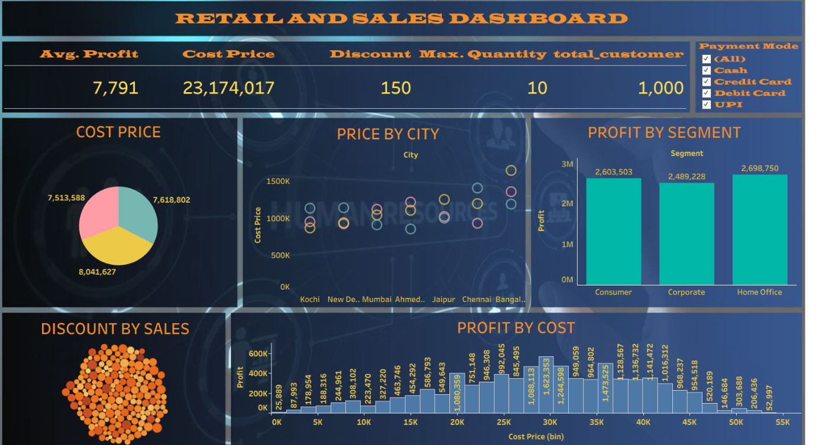

2. Objectives of the Project
The main objectives of this project are:
- To analyze retail sales data and identify key business trends.
- To visualize important metrics such as profit, cost price, and discounts.
- To compare performance across different cities and customer segments.
- To develop an interactive dashboard for business decision-making.
- To convert raw transactional data into actionable insights.

3. Dataset Description
The dataset used in this project contains 1,000 retail transactions with multiple attributes related to sales operations.
Key Columns in Dataset
- Order ID
- Customer ID
- Customer Segment
- City
- Product Category
- Product Name
- Quantity
- Cost Price
- Selling Price
- Discount
- Profit
- Payment Mode
- Order Date
The dataset provides sufficient information to analyze customer purchasing patterns, profitability, and pricing strategies.

4. Tools and Technologies Used
Tool | Purpose
Excel | Data cleaning and preprocessing
Tableau | Data visualization and dashboard creation
Data Analytics Techniques | Trend analysis and performance evaluation

5. Data Preparation
Before creating the dashboard, the dataset was cleaned and prepared using Excel. The following steps were performed:
- Removed duplicate records.
- Handled missing values.
- Formatted numeric fields such as cost price, discount, and profit.
- Organized categorical variables like city, segment, and payment mode.
- Verified data consistency for accurate visualization.
After preprocessing, the dataset was imported into Tableau for analysis and visualization.

6. Dashboard Overview
The Retail Sales Dashboard provides a visual summary of the business performance. It includes several key performance indicators and charts to help understand sales data effectively.
Key Performance Indicators (KPIs)
The dashboard displays the following KPIs:
- Average Profit: 7,791
- Total Cost Price: 23,174,017
- Maximum Discount: 150
- Maximum Quantity Sold: 10
- Total Customers: 1,000
These KPIs provide a quick overview of the business performance.

7. Dashboard Visualizations
7.1 Cost Price Distribution
A pie chart is used to show the distribution of cost prices across different product categories. This visualization helps identify which category contributes the most to the overall cost.

7.2 Price by City
A scatter plot displays the cost price distribution across different cities such as Kochi, Mumbai, Ahmedabad, Jaipur, Chennai, and Bangalore.
This chart helps to:
- Compare pricing patterns between cities
- Identify cities with higher product costs
- Understand regional pricing variations

7.3 Profit by Segment
A bar chart compares profits generated by different customer segments.
Segments included:
- Consumer
- Corporate
- Home Office
The visualization shows that the Home Office segment generated the highest profit, followed by Consumer and Corporate segments.

7.4 Discount by Sales
This visualization represents how discounts are distributed across sales transactions. It helps analyze how discount strategies affect overall sales performance.

7.5 Profit by Cost
A histogram illustrates the relationship between cost price and profit.
This analysis helps identify:
- Cost ranges generating higher profits
- Price points where profit margins increase
- Potential pricing strategies for maximizing revenue

8. Interactive Filters
The dashboard includes a Payment Mode Filter, allowing users to analyze sales based on payment methods such as:
- Cash
- Credit Card
- Debit Card
- UPI
This interactive feature helps stakeholders analyze customer payment preferences and transaction trends.

9. Key Insights from the Analysis
From the dashboard analysis, several insights were identified:
- The Home Office segment contributes the highest profit among all customer segments.
- Cities like Bangalore and Chennai show higher cost price values, indicating higher product value or demand.
- Discounts play an important role in driving sales but must be optimized to maintain profit margins.
- Payment modes such as UPI and cards are widely used, indicating a shift toward digital payments.

10. Business Recommendations
Based on the analysis, the following recommendations can be made:
- Focus marketing strategies on the Home Office segment, as it generates the highest profit.
- Optimize discount strategies to avoid reducing profit margins.
- Expand sales efforts in cities with high cost-price transactions.
- Encourage digital payment methods to improve transaction efficiency.
- Monitor product pricing to maintain competitive profit levels.

11. Limitations of the Study
- The dataset contains only 1,000 transactions, which may not fully represent real-world retail operations.
- External factors such as seasonal demand and marketing campaigns were not included in the dataset.
- Customer demographic information was limited.

12. Future Enhancements
This project can be improved by:
- Adding time-series analysis for monthly and yearly sales trends.
- Including customer demographics for deeper segmentation analysis.
- Integrating predictive analytics for forecasting sales.
- Connecting the dashboard to real-time databases.

13. Conclusion
The Retail Sales Dashboard successfully demonstrates how data visualization can transform raw data into meaningful business insights. Using Tableau, complex sales data was converted into a clear and interactive dashboard that highlights key performance indicators, customer segments, pricing patterns, and profitability trends.
This project showcases the importance of data analytics in retail decision-making and provides a foundation for future analytical solutions.

